
ReportTypeProper Report

Real Estate Appraisal

Of
PropertyName

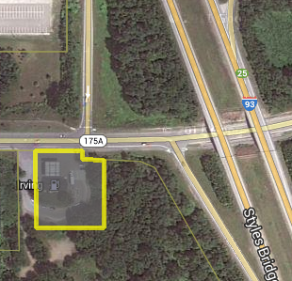

Address, City
County County
State, Zip

As of
AsIsValueDate

Prepared For
ClientSalutation ClientFirstName ClientLastName
ClientCompanyName
ClientAddress
ClientCity, ClientState, ClientZip

Client File:
ClientFileNum

Prepared by
AppraisalFirmName
Appraiser1FirstName Appraiser1LastName, Appraiser1Suffix, Appraiser1CertificationState-Appraiser1CertificationNumber
-- Appraiser2LastName, Appraiser2Suffix, Appraiser2CertificationState-Appraiser2CertificationNumber

File Name:
AppraisalFile
AppraisalFirmName
 | AppraisalFirmAddress  AppraisalFirmCity,  AppraisalFirmState, AppraisalFirmZip | AppraisalFirmPhoneNum  Fax: AppraisalFirmFaxNum  AppraisalFirmEmail  AppraisalFirmWebSite

ReportDate

ClientSalutation ClientFirstName ClientLastName
ClientCompanyName
ClientAddress
ClientCity, ClientState
ClientZip

Re: | ReportTypeProper Report, Real Estate Appraisal  PropertyName  Address, City,  County County, State, Zip  File Name: AppraisalFile

Dear ClientSalutation ClientLastName:

At your request, AuthorWeILowerCase have prepared an appraisal for the above referenced property, which may be briefly described as follows:

CapsuleDescription

Please reference page 9 of this report for important information regarding the scope of research and analysis for this appraisal, including property identification, inspection, highest and best use analysis and valuation methodology.

AuthorWeI certify that AuthorWeILowerCase have no present or contemplated future interest in the property beyond this estimate of value. PriorServices

Your attention is directed to the Limiting Conditions and Assumptions section of this report (page 7). Acceptance of this report constitutes an agreement with these conditions and assumptions. In particular, AuthorWeILowerCase note the following:

Hypothetical Conditions:

- HypotheticalConditions
- HypotheticalConditions2
- HypotheticalConditions3

ClientSalutation ClientLastName
ClientCompanyName
ReportDate
Page 2

Extraordinary Assumptions:

- ExtraordinaryAssumptions
- ExtraordinaryAssumptions2
- ExtraordinaryAssumptions3

Based on the appraisal described in the accompanying report, subject to the Limiting Conditions and Assumptions, Extraordinary Assumptions and Hypothetical Conditions (if any), AuthorWeILowerCase have made the following value conclusion(s):

AsIsValuePerspective As Is Market Value:

The “As Is” market value of the AsIsInterestAppraised estate of the property, as of AsIsValueDate, is

AsIsValueText (AsIsValue)

The market exposure time preceding AsIsValueDate would have been AsIsExposurePeriod and the estimated marketing period as of AsIsValueDate is AsIsMarketingTime.

Respectfully submitted,
AppraisalFirmName

Appraiser1FirstName Appraiser1LastName, Appraiser1Suffix  Appraiser1CertificationState-Appraiser1CertificationNumber | -- Appraiser2LastName, Appraiser2Suffix  Appraiser2CertificationState-Appraiser2CertificationNumber
Table of Contents

Summary of Important Facts and Conclusions 5
Limiting Conditions and Assumptions 7
Scope of Work 9
Market Area Analysis 11
Market Area Location and Boundaries 12
Market Area and Property Characteristics 12
Location Map 13
Property Description 14
Site Plan/Tax Map/Survey 16
Subject Photographs 18
Assessment and Taxes 20
Zoning 21
Highest and Best Use 22
Valuation Methodology 23
Analyses Applied 23
Sales Comparison Approach – Land Valuation 24
Land Comparables 24
Comparables Map 32
Analysis Grid 32
Comparable Land Sale Adjustments 34
Sales Comparison Approach Conclusion – Land Valuation 34
Final Reconciliation 35
Value Indication 35
Value Conclusion 35
Certification Statement 36
Addenda 37
Glossary 39

Summary of Important Facts and Conclusions

General
Subject: | PropertyName  Address, City,  County County, State, Zip  CapsuleDescription
Owner: | OwnerName
Legal Description: | Parcel1LegalDescription
Date of Report: | ReportDate
Intended Use: | The intended use is for ScopeIntendedUse.
Intended User(s): | The ScopeIntendedUsers.
Assessment:
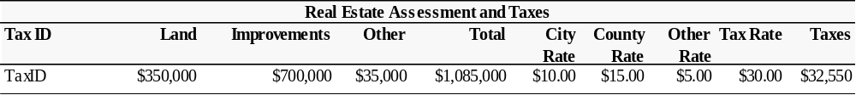

Sale History: | The subject has not sold in the last three years, according to public records.  Or:  The subject sold for MostRecentSalePriceon MostRecentSaleDate.  MostRecentSaleComment  Prior to this transaction the subject sold for OlderSalePrice on OlderSaleDate. OlderSaleComment.  PreviousSalesComments

Current Listing/Contract(s): | The subject is not currently listed for sale, or under contract.  Or:  The subject was listed by ListingAgency for ListPrice on ListDate. ListingComment  And/Or  The subject is currently under option for OptionPrice. The option date is OptionDate. OptionComment.  And/or  The subject is under contract for sale for ContractPrice.  Contract Date: ContractDate  Financing Terms: ContractFinancing  Buyer: ContractGrantee  ContractComment

Land:
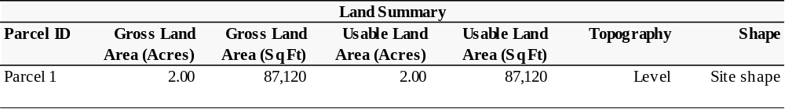

Zoning: | Zoning
Highest and Best Use  of the Site: | Parcel1HBUSite
Type of Value: | TypeOfValue

Value Indications
Sales Comparison Approach: | LandValue

Reconciled Value(s): | As Is
Value Conclusion(s) | AsIsValue
Effective Date(s) | AsIsValueDate
Property Rights | AsIsInterestAppraised

Limiting Conditions and Assumptions
Acceptance of and/or use of this report constitutes acceptance of the following limiting conditions and assumptions; these can only be modified by written documents executed by both parties.

This appraisal is to be used only for the purpose stated herein. While distribution of this appraisal in its entirety is at the discretion of the client, individual sections shall not be distributed; this report is intended to be used in whole and not in part.

No part of this appraisal, its value estimates or the identity of the firm or the appraiser(s) may be communicated to the public through advertising, public relations, media sales, or other media.

All files, work papers and documents developed in connection with this assignment are the property of AppraisalFirmName. Information, estimates and opinions are verified where possible, but cannot be guaranteed. Plans provided are intended to assist the client in visualizing the property; no other use of these plans is intended or permitted.

No hidden or unapparent conditions of the property, subsoil or structure, which would make the property more or less valuable, were discovered by the appraiser(s) or made known to the appraiser(s). No responsibility is assumed for such conditions or engineering necessary to discover them. Unless otherwise stated, this appraisal assumes there is no existence of hazardous materials or conditions, in any form, on or near the subject property.

Unless otherwise stated in this report, the existence of hazardous substances, including without limitation asbestos, polychlorinated biphenyl, petroleum leakage, or agricultural chemicals, which may or may not be present on the property, was not called to the attention of the appraiser nor did the appraiser become aware of such during the appraiser’s inspection. The appraiser has no knowledge of the existence of such materials on or in the property unless otherwise stated. The appraiser, however, is not qualified to test for such substances. The presence of such hazardous substances may affect the value of the property. The value opinion developed herein is predicated on the assumption that no such hazardous substances exist on or in the property or in such proximity thereto, which would cause a loss in value. No responsibility is assumed for any such hazardous substances, nor for any expertise or knowledge required to discover them.

Unless stated herein, the property is assumed to be outside of areas where flood hazard insurance is mandatory. Maps used by public and private agencies to determine these areas are limited with respect to accuracy. Due diligence has been exercised in interpreting these maps, but no responsibility is assumed for misinterpretation.

Good title, free of liens, encumbrances and special assessments is assumed. No responsibility is assumed for matters of a legal nature.

Necessary licenses, permits, consents, legislative or administrative authority from any local, state or Federal government or private entity are assumed to be in place or reasonably obtainable.

It is assumed there are no zoning violations, encroachments, easements or other restrictions which would affect the subject property, unless otherwise stated.

The appraiser(s) are not required to give testimony in Court in connection with this appraisal. If the appraisers are subpoenaed pursuant to a court order, the client agrees to pay the appraiser(s) AppraisalFirmName’s regular per diem rate plus expenses.

Appraisals are based on the data available at the time the assignment is completed. Amendments/modifications to appraisals based on new information made available after the appraisal was completed will be made, as soon as reasonably possible, for an additional fee.

Americans with Disabilities Act (ADA) of 1990
A civil rights act passed by Congress guaranteeing individuals with disabilities equal opportunity in public accommodations, employment, transportation, government services, and telecommunications. Statutory deadlines become effective on various dates between 1990 and 1997. AppraisalFirmName has not made a determination regarding the subject’s ADA compliance or non-compliance. Non-compliance could have a negative impact on value, however this has not been considered or analyzed in this appraisal.

Scope of Work
According to the Uniform Standards of Professional Appraisal Practice, it is the appraiser’s responsibility to develop and report a scope of work that results in credible results that are appropriate for the appraisal problem and intended user(s). Therefore, the appraiser must identify and consider:

● the client and intended users;
● the intended use of the report;
● the type and definition of value;
● the effective date of value;
● assignment conditions;
● typical client expectations; and
● typical appraisal work by peers for similar assignments.

This appraisal is prepared for ClientSalutation ClientFirstName ClientLastName, ClientTitle ClientCompanyName. The problem to be solved is ScopeProblemToBeSolved. The intended use is for ScopeIntendedUse. This appraisal is intended for the use of ScopeIntendedUsers.

Scope of Work
Report Type: |  | ReportTypeDescription
Property Identification: |  | ScopePropertyID
Inspection: |  | ScopeInspection
Market Area and Analysis of Market Conditions: |  | ScopeMarketAnalysis
Highest and Best Use Analysis: |  | ScopeOfHBU
Type of Value: |  | TypeOfValue
Valuation Analyses
Cost Approach: |  | A cost approach ScopeCost applied as ScopeCostLogic
Sales Comparison Approach: |  | A sales approach ScopeSales applied as ScopeSalesLogic
Income Approach: |  | An income approach ScopeIncome applied as ScopeIncomeLogic
Hypothetical Conditions: | - HypotheticalConditions  - HypotheticalConditions2  - HypotheticalConditions3
Extraordinary Assumptions: | - ExtraordinaryAssumptions  - ExtraordinaryAssumptions2  - ExtraordinaryAssumptions3
Information Not Available: | - ScopeInfoNotAvailable  - ScopeInfoNotAvailable2  - ScopeInfoNotAvailable3

Comments

Market Area Analysis
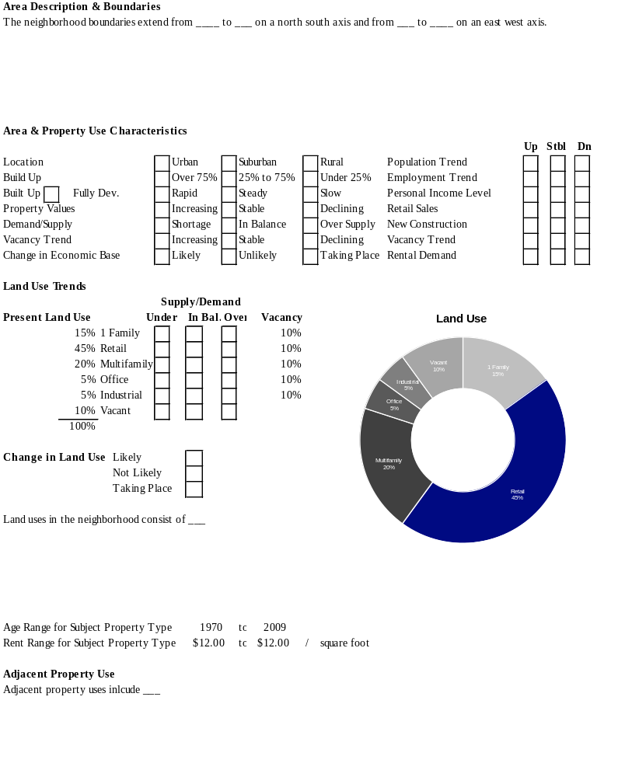
Optional narrative headings – delete if using table above

Market Area Location and Boundaries
Describe

Market Area and Property Characteristics
Describe

Population Trends
Describe/Analyze

Housing Trends
Describe/Analyze

Income Trends
Describe/Analyze

Major Employers
Describe/Analyze

Unemployment Trends
Describe/Analyze

Land Use Trends
Describe/Analyze

Location Map

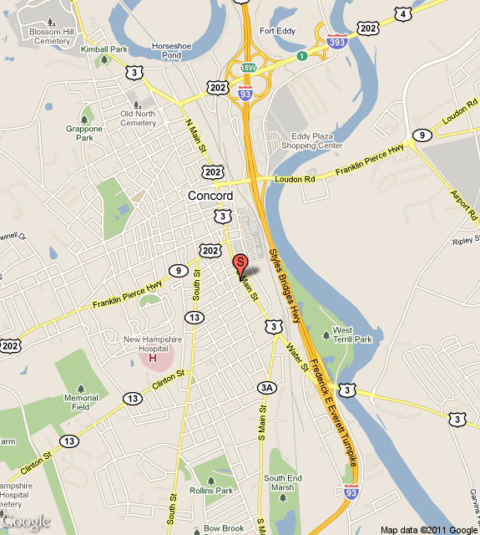

Property Description
CapsuleDescription

Multiple parcels table – delete if only one parcel

Site
Location: | Parcel1Location
Current Use of the Property: | Parcel1CurrentUse
Site Size: | Total: Parcel1Acres acres; Parcel1SF square feet  Usable: Parcel1UsableAcres acres; Parcel1UsableSF square feet  Parcel1UsableLandComments
Shape: | Parcel1Shape
Frontage/Access: | The subject property has Parcel1Access access with frontage as follows:  - Parcel1PrimaryFrontageStreetName: Parcel1PrimaryStreetFrontage feet  - Parcel1SecondaryFrontageStreetName: Parcel1SecondaryStreetFrontage feet  The site has an average depth of Parcel1AverageDepth feet. It Parcel1CornerLot a corner lot.
Visibility: | Parcel1Visibility
Topography: | Parcel1Topography
Soil Conditions: | Parcel1SoilConditions
Utilities: | Electricity: Parcel1Electricity  Sewer: Parcel1Sewer  Water: Parcel1Water  Natural Gas: Parcel1Gas  Underground Utilities: Parcel1UndergroundUtilities  Adequacy: Parcel1UtilitesAdequacy
Site Improvements: | - Parcel1StreetLights  - Parcel1Sidewalk  - Parcel1CurbGutter  - Parcel1Landscaping
Flood Zone: | The subject is located in an area mapped by the Federal Emergency Management Agency (FEMA). The subject is located in FEMA flood zone Parcel1FloodZone, which Parcel1FloodZoneIsIsNot classified as a flood hazard area.  FEMA Map Number: Parcel1FEMAMapNumber  FEMA Map Date: Parcel1FEMAMapDate  Parcel1FloodZoneComments
Wetlands/Watershed: | Parcel1WetlandsWatershedComments
Environmental Issues: | Parcel1EnvironmentalIssues
Encumbrance / Easements: | Parcel1EncumbranceorEasement
Site Comments: | SiteComnt

Insert Site #2 here (How?)

Site Plan/Tax Map/Survey

Americans with Disabilities Act
Please reference the Limiting Conditions and Assumptions section of this report on page 8.

Hazardous Substances
Please reference the Limiting Conditions and Assumptions section of this report on page 8.

Subject Photographs

Picture Here
Description Here
Picture Here
Description Here

Picture Here
Description Here
Picture Here
Description Here

Assessment and Taxes

Taxing Authority | AssessmentParcel1TaxingAuthority
Assessment Year | AssessmentParcel1TaxYear

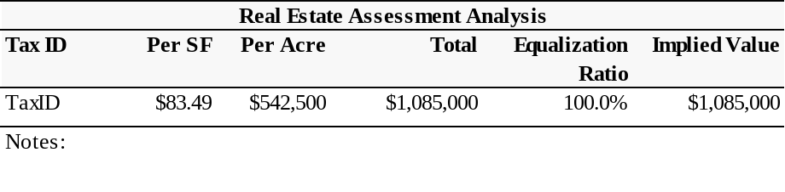
Comments
AssessmentComments

Zoning
Land Use Controls
Zoning Code | Zoning
Zoning Description | ZoningDescription
Zoning Density/FAR | BuildingsFAR
Actual Density of Use | Density
Current Use Legally Conforming | ZoningLegallyConforming
Zoning Change Likely | ZoningChangeLikely
Zoning Change Description | ZoningChangeDescription
Set Back Distance | ZoningSetBackDistance
Side Yard Distance | ZoningSideYardDistance
Zoning Comments | ZoningComments

Highest and Best Use
Highest and best use may be defined as the reasonably probable and legal use of vacant land or improved property, which is physically possible, appropriately supported, financially feasible, and that results in the highest value.

- Legally Permissible: What uses are permitted by zoning and other legal restrictions?

- Physically Possible: To what use is the site physically adaptable?

- Financially Feasible: Which possible and permissible use will produce any net return to the owner of the site?

- Maximally Productive. Among the feasible uses which use will produce the highest net return, (i.e., the highest present worth)?

Highest and Best Use of the Site
The highest and best use of the site, as vacant, is for Parcel1HBUSite.

Parcel1HBUSiteComment

Highest and Best Use as Improved
The highest and best use of the subject as improved Building1HBU.

HBU as improved comments

Valuation Methodology
Three basic approaches may be used to arrive at an estimate of market value. They are:

- The Cost Approach
- The Income Approach
- The Sales Comparison Approach

Cost Approach
The Cost Approach is summarized as follows:

Cost New
- Depreciation
+ Land Value
= Value

Income Approach
The Income Approach converts the anticipated flow of future benefits (income) to a present value estimate through a capitalization and or a discounting process.

Sales Comparison Approach
The Sales Comparison Approach compares sales of similar properties with the subject property. Each comparable sale is adjusted for its inferior or superior characteristics. The values derived from the adjusted comparable sales form a range of value for the subject. By process of correlation and analysis, a final indicated value is derived.

Final Reconciliation
The appraisal process concludes with the Final Reconciliation of the values derived from the approaches applied for a single estimate of market value. Different properties require different means of analysis and lend themselves to one approach over the others.

Analyses Applied
A cost analysis was considered and ScopeCost developed because ScopeCostLogic

A sales comparison analysis was considered and ScopeSales developed because ScopeSalesLogic
An income analysis was considered and ScopeIncome developed because ScopeIncomeLogic

Sales Comparison Approach – Land Valuation
The Sales Comparison Approach is based on the premise that a buyer would pay no more for a specific property than the cost of obtaining a property with the same quality, utility, and perceived benefits of ownership. It is based on the principles of supply and demand, balance, substitution and externalities. The following steps describe the applied process of the Sales Comparison Approach.

- The market in which the subject property competes is investigated; comparable sales, contracts for sale and current offerings are reviewed.

- The most pertinent data is further analyzed and the quality of the transaction is determined.

- The most meaningful unit of value for the subject property is determined.

- Each comparable sale is analyzed and where appropriate, adjusted to equate with the subject property.

- The value indication of each comparable sale is analyzed and the data reconciled for a final indication of value via the Sales Comparison Approach.

Land Comparables
AuthorWeI have researched NumberOfLandCompsUsed comparables for this analysis; these are documented on the following pages followed by a location map and analysis grid. All sales have been researched through numerous sources, inspected and verified by a party to the transaction.

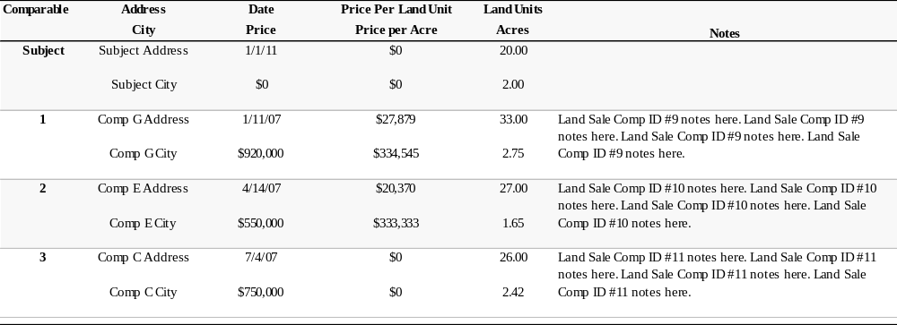
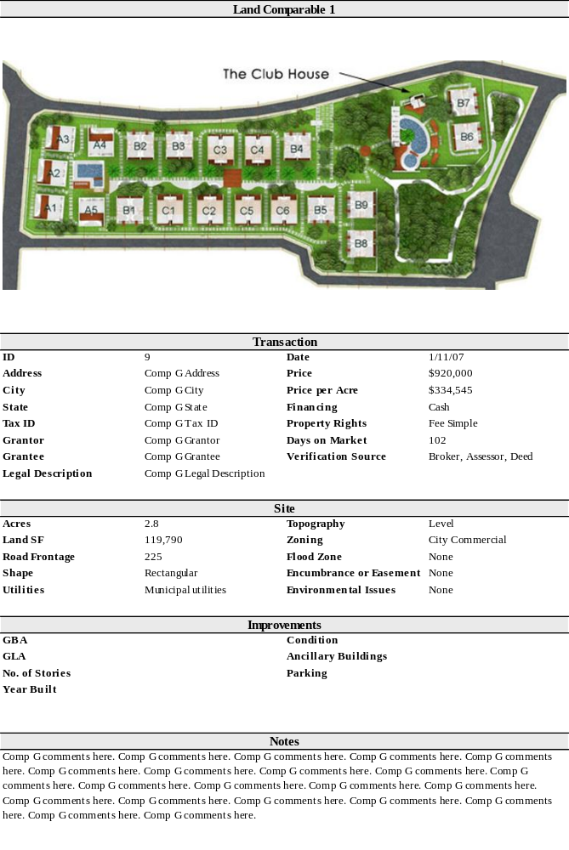
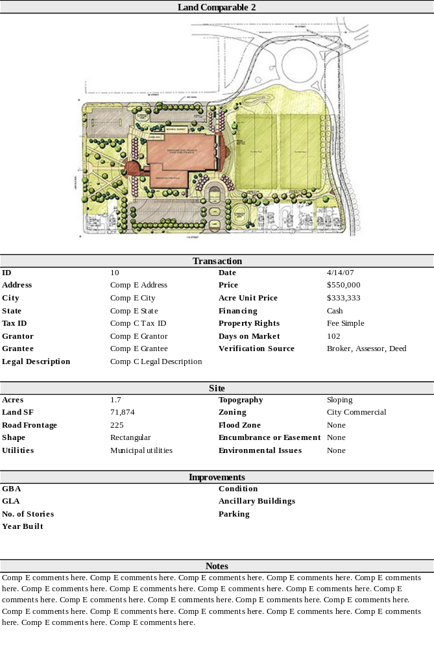
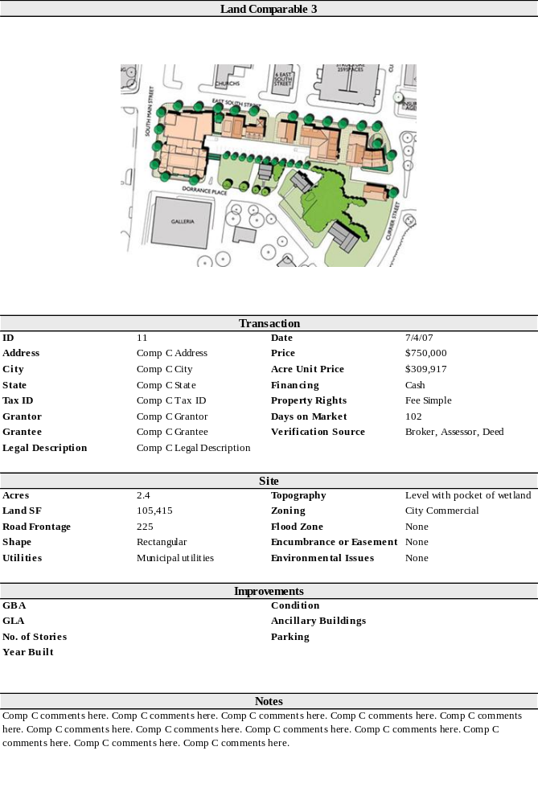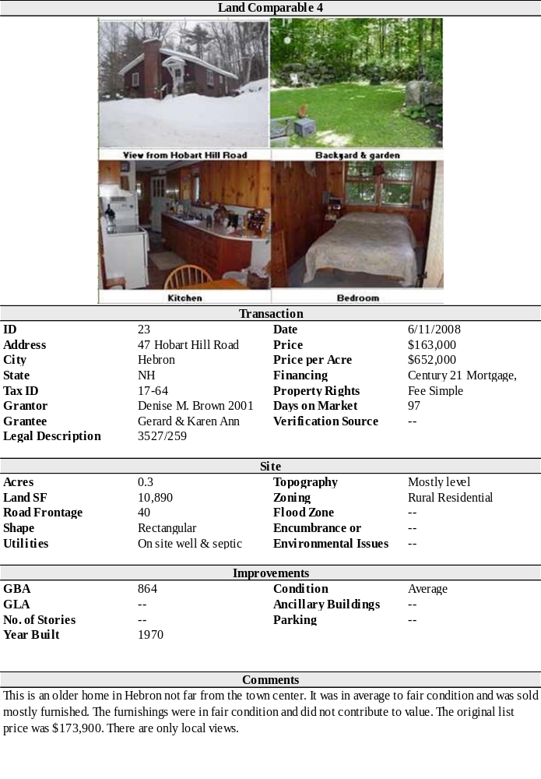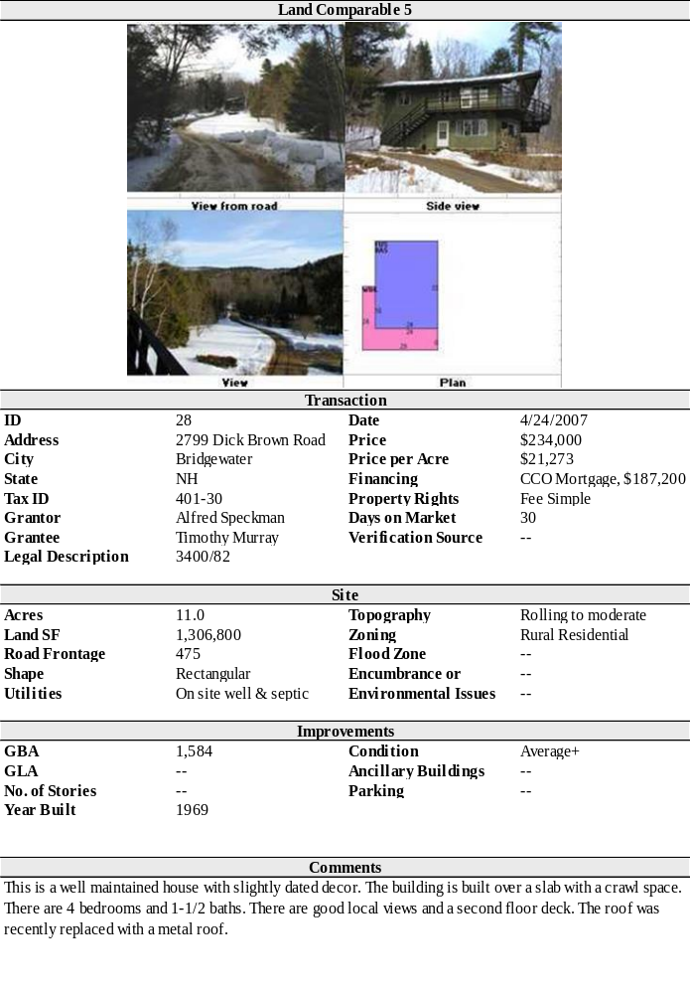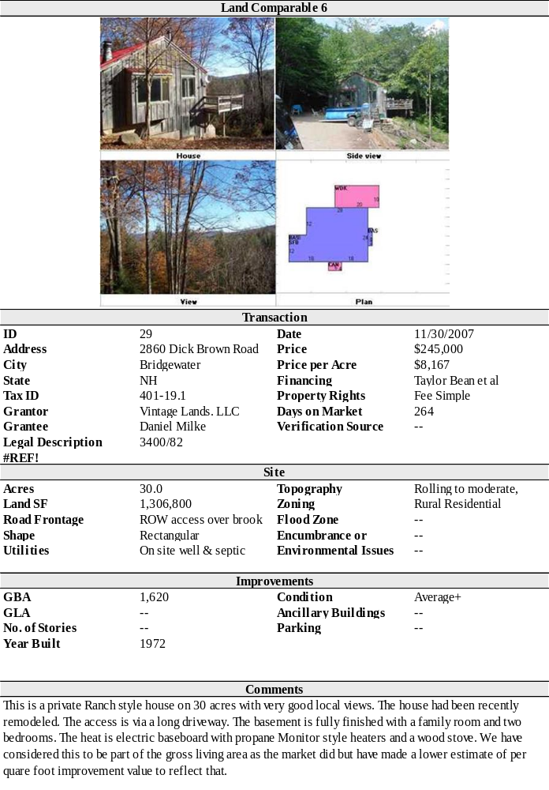
To insert more comp sheets:
By default, the Narrative1 template displays six comps for Land, Sales and Leases. To add more:
- Create a new blank page in Word
- Right-click and select Fields and Tables (or use the Narrative1 menu from Word’s main menu.)
- Find the comps in the list, select it and click insert

Comparables Map

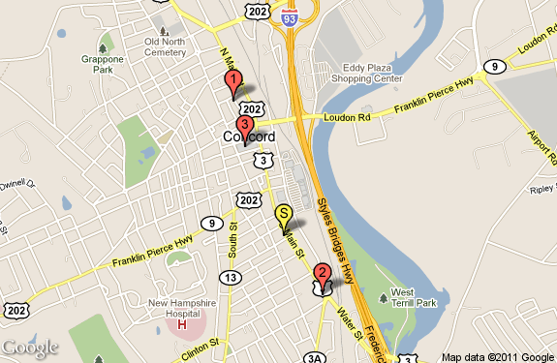

Analysis Grid
The above sales have been analyzed and compared with the subject property. AuthorWeI have considered adjustments in the areas of:

 Property Rights Sold   Financing   Conditions of Sale |  Market Trends   Location   Physical Characteristics

On the following page is a sales comparison grid displaying the subject property, the comparables and the adjustments applied.

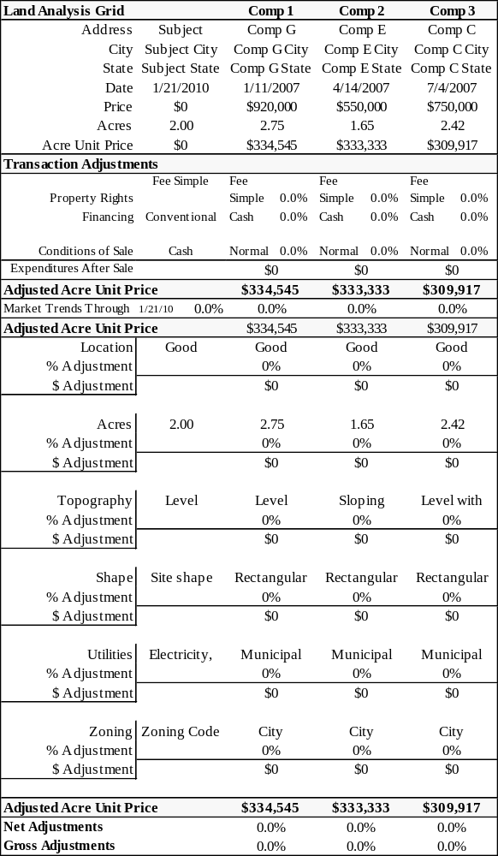

Comparable Land Sale Adjustments

Property Rights
4 Describe/Analyze3

Financing
4 Describe/Analyze3

Conditions of Sale
4 Describe/Analyze3

Economic Trends
4 Describe/Analyze3

LandGridAdj1
4 Describe/Analyze3

LandGridAdj2
4 Describe/Analyze3

LandGridAdj3
4 Describe/Analyze3

LandGridAdj4
4 Describe/Analyze3

LandGridAdj5
4 Describe/Analyze3

Sales Comparison Approach Conclusion – Land Valuation
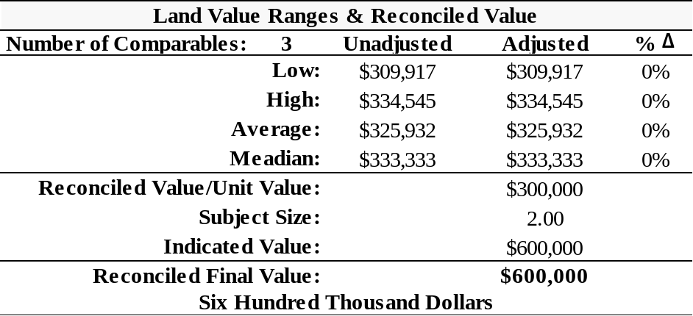
All of the value indications have been considered, and in the final analysis, comparables <#>, <#> and <#>, have been given most weight in arriving at AuthorMyOurLowerCase final reconciled per LandGridUnitOfComparison value of LandGridReconciledValue.

Final Reconciliation
The process of reconciliation involves the analysis of each approach to value. The quality of data applied, the significance of each approach as it relates to market behavior and defensibility of each approach are considered and weighed. Finally, each is considered separately and comparatively with each other.

Value Indication
Sales Comparison Approach – Land Value: | LandValue

Sales Comparison Approach
4Discuss data quality, quantity and relevance of approach3

Value Conclusion
Based on the data and analyses developed in this appraisal, AuthorWeILowerCase have reconciled to the following value conclusion(s), as of AsIsValueDate, subject to the Limiting Conditions and Assumptions of this appraisal.

Reconciled Value(s): | Premise: As Is  Interest: AsIsInterestAppraised  Value Conclusion: AsIsValue  AsIsValueText

Certification Statement
AuthorWeI certify that, to the best of AuthorMyOurLowerCase knowledge and belief:

- The statements of fact contained in this report are true and correct.
- The reported analyses, opinions and conclusions are limited only by the reported assumptions and limiting conditions, and are AuthorMyOurLowerCase personal, impartial, and unbiased professional analyses, opinions and conclusions.
- AuthorWeI have no present or prospective future interest in the property that is the subject of this report, and have no personal interest with respect to the parties involved.
- AuthorWeI have no bias with respect to the property that is the subject of this report, or to the parties involved with this assignment.
- AuthorMyOur engagement in this assignment was not contingent upon developing or reporting predetermined results.
- AuthorMyOur compensation for completing this assignment is not contingent upon the development or reporting of a predetermined value or direction in value that favors the cause of the client, the amount of the value estimate, the attainment of a stipulated result, or the occurrence of a subsequent event directly related to the intended use of this appraisal.
- AuthorMyOur analyses, opinions, and conclusions were developed, and this report has been prepared, in conformity with the Uniform Standards of Professional Appraisal Practice (USPAP).
- No one provided significant real property appraisal assistance to the person(s) signing this certification.
- AuthorWeI certify sufficient competence to appraise this property through education and experience, in addition to the internal resources of the appraisal firm.
- PriorServices
- Appraiser1FirstName Appraiser1LastName Appraiser1Inspection made an inspection of the subject property.
- -- Appraiser2LastName Appraiser2Inspection made an inspection of the subject property.

See N1 Autotext Misc category for Appraisal Institute certification statements
Appraiser1FirstName Appraiser1LastName, Appraiser1Suffix  Appraiser1CertificationState-Appraiser1CertificationNumber | -- Appraiser2LastName, Appraiser2Suffix  Appraiser2CertificationState-Appraiser2CertificationNumber

Addenda

Qualifications Placeholder Page

Glossary
This glossary contains the definitions of common words and phrases, used throughout the appraisal industry, as applied within this document. Please refer to the publications listed in the Works Cited section below for more information.

Works Cited:
- Appraisal Institute. The Appraisal of Real Estate. 14th ed. Chicago: Appraisal Institute, 2013. Print.
- Appraisal Institute. The Dictionary of Real Estate Appraisal. 6th ed. 2015. Print.

Band of Investment
A technique in which the capitalization rates attributable to components of an investment are weighted and combined to derive a weighted-average rate attributable to the total investment (i.e., debt and equity, land and improvements).
(Dictionary, 6th Edition)

Common Area
- The total area within a property that is not designed for sale or rental but is available for common use by all owners, tenants, or their invitees, e.g., parking and its appurtenances, malls, sidewalks, landscaped areas, recreation areas, public toilets, truck and service facilities.
- In a shopping center, the walkways and areas onto which the stores face and which conduct the flow of customer traffic. (ICSC) (Dictionary, 6th Edition)

Common Area Maintenance (CAM)
- The expense of operating and maintaining common areas; may or may not include management charges and usually does not include capital expenditures on tenant improvements or other improvements to the property.
- CAM can be a line-item expense for a group of items that can include maintenance of the parking lot and landscaped areas and sometimes the exterior walls of the buildings.
- CAM can refer to all operating expenses.
- CAM can refer to the reimbursement by the tenant to the landlord for all expenses reimbursable under the lease. Sometimes reimbursements have what is called an administrative
load. An example would be a 15% addition to total operating expenses, which are then prorated among tenants. The administrative load, also called an administrative and marketing fee, can be a substitute for or an addition to a management fee.
- The amount of money charged to tenants for their shares of maintaining a center’s common area. The charge that a tenant pays for shared services and facilities such as electricity, security, and maintenance of parking lots. Items charged to common area maintenance may include cleaning services, parking lot sweeping and maintenances, snow removal, security, and upkeep. (ICSC) (Dictionary, 6th Edition)

Debt Coverage Ratio (DCR)
The ratio of net operating income to annual debt service (DCR = NOI/Im), which measures the relative ability of a property to meet its debt service out of net operating income; also called debt service coverage ratio (DSCR). A larger DCR indicates a greater ability for a property to withstand a downturn in revenue, providing an improved safety margin for a lender. (Dictionary, 6th Edition)

Discount Rate
A rate on return on capital used to convert future payments or receipts into present value; usually considered to be a synonym for yield rate. (Dictionary, 6th Edition)

Effective Age
The age of property that is based on the amount of observed deterioration and obsolescence it has sustained, which may be different from its chronological age. (Dictionary, 6th Edition)

Effective Date
- The date on which the appraisal or review opinion applies. (SVP)
- In a lease document, the date upon which the lease goes into effect.

Exposure Time
- The time a property remains on the market.
- The estimated length of time the property interest being appraised would have been offered on the market prior to the hypothetical consummation of a sale at market value on the effective date of the appraisal; a retrospective estimate based on an analysis of past events assuming a competitive and open market. (Dictionary, 6th Edition)

External Obsolescence
A type of depreciation; a diminution in value caused by negative externalities and generally incurable on the part of the owner, landlord, or tenant. The external influence may be either temporary or permanent (Dictionary, 6th Edition).

Extraordinary Assumption
An assumption, directly related to a specific assignment, as of the effective date of the assignment results, which, if found to be false, could alter the appraiser’s opinion or conclusion. Comment: Extraordinary assumptions presume as fact otherwise uncertain information about physical, legal, or economic characteristics of the subject property; or about conditions external to the property, such as market conditions or trends; or about the integrity of data used in an analysis. (USPAP, 2016-2017 ed.) (Dictionary, 6th Edition)

Fee Simple Estate
Absolute ownership unencumbered by any other interest or estate, subject only to the limitations imposed by the governmental powers of taxation, eminent domain, police power, and escheat. (Dictionary, 6th Edition)

Functional Obsolescence
The impairment of functional capacity of a property according to market tastes and standards. (Dictionary, 6th Edition)

Functional Utility
The ability of a property or building to be useful and to perform the function for which it is intended according to current market tastes and standards; the efficiency of a building’s use in terms of architectural style, design and layout, traffic patterns, and the size and type of rooms. (Dictionary, 6th Edition)

Gross Building Area (GBA)
- Total floor area of a building, excluding unenclosed areas, measured from the exterior of the walls of the above grade area. (Dictionary, 6th Edition)

Gross Leasable Area (GLA)
Total floor area designed for the occupancy and exclusive use of tenants, including basements and mezzanines; measured from the center of joint partitioning to the outside wall surfaces. (Dictionary, 6th Edition)

Highest & Best Use
The reasonably probable use of property that results in the highest value. The four criteria that the highest and best legal use must meet are legal permissibility, physical possibility, financial feasibility, and maximum productivity. (Dictionary, 6th Edition)

Hypothetical Condition
A condition, directly related to a specific assignment, which is contrary to what is known by the appraiser to exist on the effective date of the assignment results, but it is used for the purpose of analysis. Comment: Hypothetical conditions are contrary to known facts about physical, legal, or economic characteristics of the subject property; or about conditions external to the property, such as market conditions or trends; or about the integrity of data used in an analysis. (USPAP, 2016-2017 ed.) (Dictionary, 6th Edition)

Leased Fee Interest
The ownership interest held by the lessor, which includes the right to receive the contract rent specified in the lease plus the revisionary right when the lease expires.
(Dictionary, 6th Edition)

Market Area
The geographic region from which a majority of demand comes in which the majority of competition is located. Depending on the market, a market area may be further subdivided into components such as primary, secondary, and tertiary market areas, or the competitive market area may be distinguished from the general market area. (Dictionary, 6th Edition)

Market Rent
The most probable rent that a property should bring in a competitive and open market reflecting the conditions and restrictions of a specified lease agreement, including the rental adjustment and reevaluation, permitted uses, use restrictions, expense obligations, term, concessions, renewal and purchase options, and tenant improvements (TIs). (Dictionary, 6th Edition)

Market Value
A type of value that is the major focus of most real property appraisal assignments. Both economic and legal definitions of market value have been developed and refined, such as the following:
- The most widely accepted components of market value are incorporated in the following definition: The most probable price, as of a specified date, in cash, or in terms equivalent to cash, or in other precisely revealed terms, for which the specified property rights should sell after a reasonable exposure in a competitive market under all conditions requisite to a fair sale, with the buyer and seller each acting prudently, knowledgably, and for self-interest, and assuming that neither is under undue duress.
- Market value is described, not defined, in the Uniform Standards of Professional Appraisal Practice (USPAP) as follows: A type of value, stated as an opinion, that presumes the transfer of a property (i.e., a right of ownership or a bundle of such rights), as of a certain date, under specific conditions set forth in the definition of the term identified by the appraiser as applicable in an appraisal.
USPAP also requires that certain items be included in every appraisal report. Among these items, the following are directly related to the definition of market value:
- Identification of the specific property rights to be appraised.
- Statement of the effective date of the value opinion.
- Specification as to whether cash, terms equivalent to cash, or other precisely described financing terms are assumed as the basis of the appraisal.
- If the appraisal is conditioned upon financing or other terms, specification as to whether the financing or terms are at, below, or above market interest rates and/or contain unusual conditions or incentives. The terms of above—or below—market interest rates and/or other special incentives must be clearly set forth; their contribution to, or negative influence on, value must be described and estimated; and the market data supporting the opinion of value must be described and explained.
- The following definition of market value is used by agencies that regulate federally insured financial institutions in the United States: The most probable price that a property should bring in a competitive and open market under all conditions requisite to a fair sale, the buyer and the seller each acting prudently and knowledgeably, and assuming the price is not affected by undue stimulus. Implicit in this definition is the consummation of a sale as of a specified date and the passing of title from seller to buyer under conditions whereby:
- Buyer and seller are typically motivated;
- Both parties are well informed or well advised, and acting in what they consider their best interests;
- A reasonable time is allowed for exposure in the open market;
- Payment is made in terms of cash in U.S. dollars or in terms of financial arrangements comparable thereto; and
- The price represents the normal consideration for the property sold unaffected by special or creative financing or sales concessions granted by anyone associated with the sale.
(12 C.F.R. Part 34.42(g); 55 Federal Register 34696, August 24, 1990, as amended at 57 Federal Register 12202, April 9, 1992; 59 Federal Register 29499, June 7, 1994)
- The International Valuation Standards Council defines market value for the purpose of international standards as follows: The estimated amount for which an asset or liability should exchange on the valuation date between a willing buyer and a willing seller in an arm’s length transaction, after proper marketing and where the parties had each acted knowledgably, prudently and without compulsion. (IVS)
- The Uniform Standards for Federal Land Acquisitions defines market value as follows: Market value is the amount in cash, or on terms reasonably equivalent to cash, for which in all probability the property would have sold on the effective date for the appraisal, after a reasonable exposure time on the open competitive market, from a willing and reasonably knowledgeable buyer, with neither acting under any compulsion to buy or sell, giving due consideration to all available economic uses of the property at the time of the appraisal. (Uniform Standards for Federal Land Acquisitions) (Dictionary, 6th Edition)

Marketing Time
An opinion of the amount of time it might take to sell a real or personal property interest at the concluded market value level during the period immediately after the effective date of the appraisal. Marketing time differs from exposure time, which is always presumed to precede the effective date of an appraisal. (Advisory Opinion 7 of the Standards Board of The Appraisal Foundation and Statement on Appraisal Standards No. 6, “Reasonable Exposure Time in Real Property and Personal Property Market Value Opinions” address the determination of reasonable exposure and marketing time). (Dictionary, 6th Edition)

Net Operating Income (NOI)
The actual or anticipated net income that remains after all operating expenses are deducted from effective gross income but before mortgage debt service and book depreciation are deducted. Note: This definition mirrors the convention used in corporate finance and business valuation for EBITDA (earnings before interest taxes, depreciation, and amortization) (Dictionary, 6th Edition)
Obsolescence
One cause of depreciation; an impairment of desirability and usefulness caused by new inventions, changes in design, improved processes for production, or external factors that make a property less desirable and valuable for a continued use; may be either functional or external. (Dictionary, 6th Edition)

Parking Ratio
A ratio of parking area or parking spaces to an economic or physical unit of comparison. Minimum required parking ratios of various land uses are often stated in zoning ordinances. (Dictionary, 6th Edition)

Rentable Area
For office buildings, the tenant’s pro rata portion of the entire office floor, excluding elements of the building that penetrate through the floor to the areas below. The rentable area of a floor is computed by measuring to the inside finished surface of the dominant portion of the permanent building walls, excluding any major vertical penetrations of the floor. Alternatively, the amount of space on which the rent is based; calculated according to local practice. (Dictionary, 6th Edition)

Replacement Cost
The estimated cost to construct, at current prices as of the effective appraisal date, a substitute for the building being appraised, using modern materials and current standards, design, and layout. (Dictionary, 6th Edition)

Scope of Work
The type and extent of research and analyses in an appraisal or appraisal review assignment. (USPAP, 2016-2017 ed.)

Stabilized Occupancy
An expression of the average or typical occupancy that would be expected for a property over a specified projection period or over its economic life. (Dictionary, 6th Edition)

Tenant Improvements (TIs)
- Fixed improvements to the land or structures installed and paid for use by a lessee.
- The original installation of finished tenant space in a construction project; subject to periodic change for succeeding tenants. (Dictionary, 6th Edition)

Vacancy and Collection Loss
A deduction from potential gross income (PGI) made to reflect income reductions due to vacancies, tenant turnover, and non-payment of rent; also called vacancy and credit loss or vacancy and contingency loss. (Dictionary, 6th Edition)

